U.S. Equity Sector Rotation Framework

Research & Implementation Handbook

1. Project objective
Build a systematic long-only U.S. equity sector-rotation strategy that converts a proprietary price/trend indicator into dynamic active sector weights.
The central research question is:
Can state-dependent trend signals improve U.S. equity sector allocation relative to the S&P 500 and a conventional time-series momentum sector-rotation strategy?
The strategy should remain predominantly/fully invested in U.S. equities. It should not require outright short positions.
Instead, bearish signals create relative underweights, while attractive signals create relative overweights.
The project should be implemented initially in Google Colab, where portfolio states, weights, signals and performance attribution can be inspected easily.
QuantConnect/LEAN can subsequently be used as an implementation validation exercise if desired.

2. Motivation
The conceptual inspiration is traditional business-cycle sector rotation.
Different equity sectors tend to perform differently through economic expansions, slowdowns, contractions and recoveries. Traditional approaches attempt to identify the economic regime using variables such as:
- GDP/growth;
- PMI/business surveys;
- inflation;
- interest rates;
- earnings;
- valuation;
- macroeconomic leading indicators;
- fundamental factors.
This framework deliberately takes a different approach.

Do not explicitly model the business cycle.
Instead, allow sector prices themselves to reveal their changing trend states.
The hypothesis is that sector prices aggregate changing expectations about economic conditions. Consequently, transitions between sectors may become visible in their respective price trends before or during changes in the economic cycle.
The framework therefore turns qualitative sector-rotation theory into an explicit systematic allocation protocol:
$$\text{Sector prices}→\text{trend states}→\text{active weights}→\text{portfolio returns}$$
Business-cycle interpretation should primarily occur afterward as performance analysis, rather than being an input into the trading algorithm.

3. Keep the initial research deliberately simple
A major design constraint is minimizing complexity and implementation time.
The initial project should therefore avoid:
- machine learning;
- explicit macroeconomic regime classification;
- fundamental-factor models;
- covariance optimization;
- maximum-Sharpe optimization;
- individual-stock selection;
- futures;
- outright short positions;
- leverage;
- complicated transaction/collateral models;
- excessive parameter optimization.
The purpose is not to construct the theoretically optimal portfolio.
The purpose is to answer one clean empirical question about sector allocation signals.

4. Investment universe
Start with the standard 11 GICS U.S. equity sectors, represented using highly liquid U.S.-listed sector ETFs.
The sectors are:
- Communication Services
- Consumer Discretionary
- Consumer Staples
- Energy
- Financials
- Health Care
- Industrials
- Information Technology
- Materials
- Real Estate
- Utilities
A natural implementation candidate is the SPDR sector ETF family, subject to checking historical availability and classification consistency.
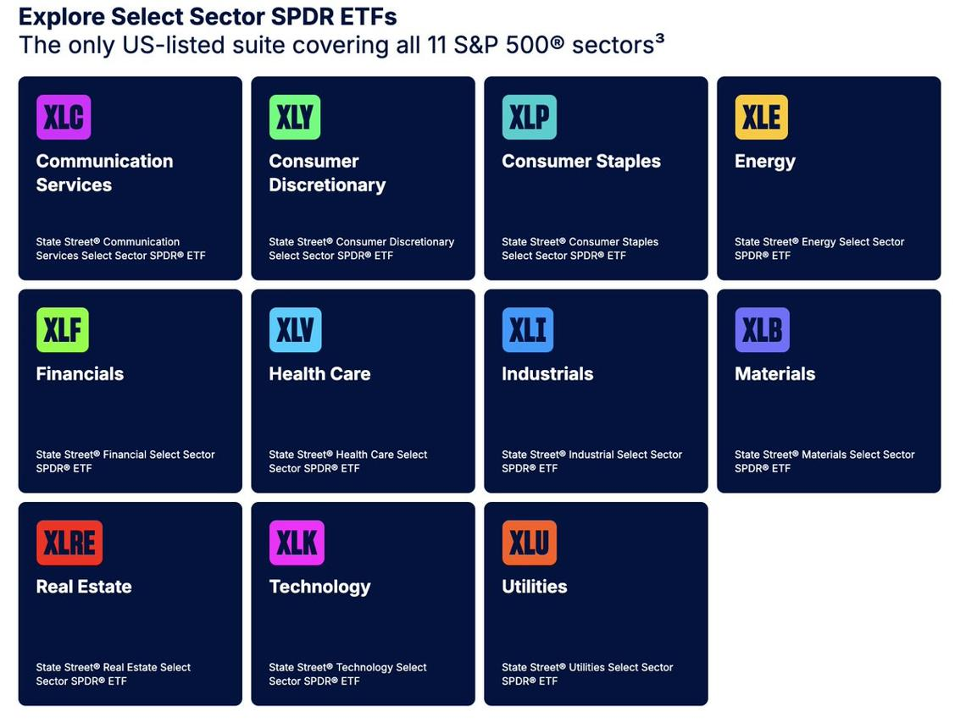
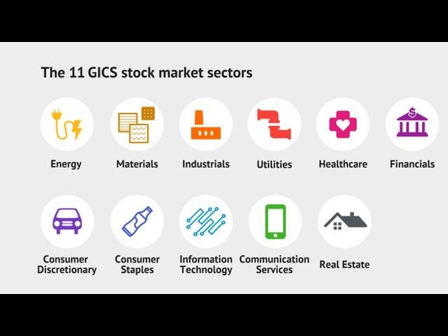
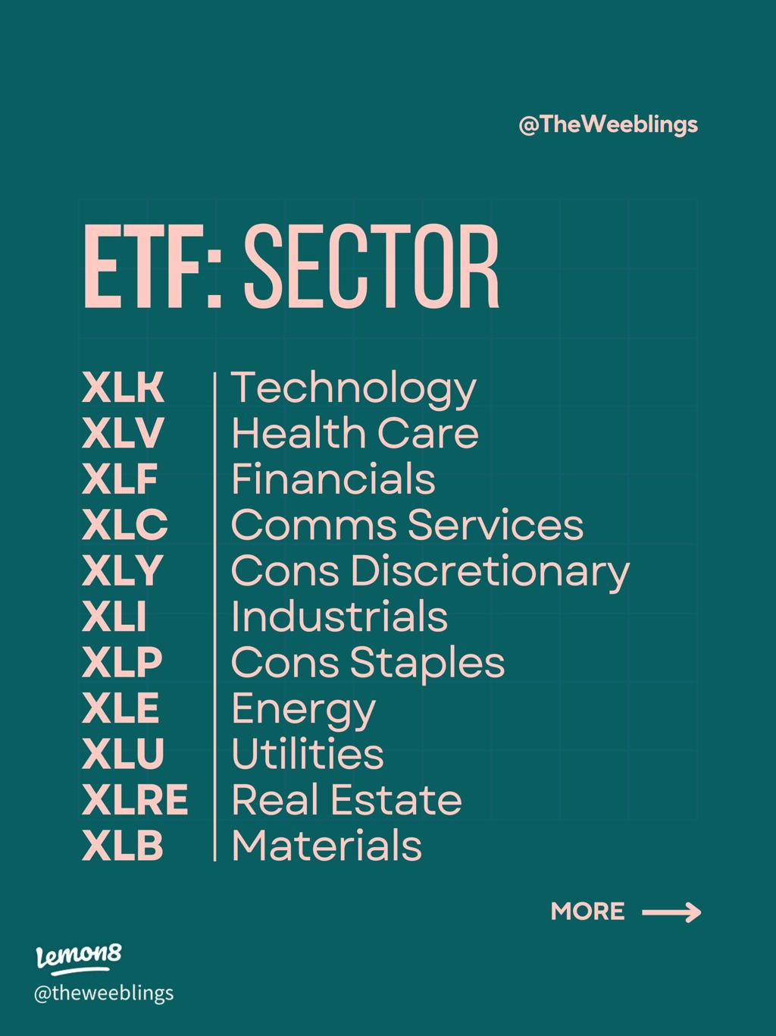
4
Do not initially add hand-picked industries such as automobiles.
Automotive equities are an attractive subsequent case study, but the first experiment benefits from having a standard, defensible, ex-ante universe rather than one selected according to expected results.

5. Frequency
Use weekly observations and weekly portfolio decisions.
This is consistent with the original indicator design and avoids turning the framework into a high-turnover strategy.
All signals must use information available at or before the rebalance date.
Avoid look-ahead bias throughout.

6. Strategic versus active allocation
This distinction is fundamental.
Every sector has a strategic/benchmark allocation and an active adjustment.
Conceptually:
$$w_{i,t}=w_{i,t}^{Strategic}+a_{i,t}$$
or, preferably for implementation:
$$\boxed{w_{i,t}=w_{i,t}^{Strategic}\left(1+A_{i,t}\right)}$$
where:
- $w_{i,t}^{Strategic}$= neutral sector allocation;
- $A_{i,t}$= active percentage overweight/underweight generated by the signal.
The resulting raw portfolio weights are then normalized appropriately.

Example
If Technology's strategic allocation is 25% and the strategy assigns it a +20% active multiplier:
$$25\%×1.20=30\%$$
If Utilities has a strategic weight of 5% and receives a −40% multiplier:
$$5\%×0.60=3\%.$$
Thus the strategy can be relatively long Technology and relatively short Utilities without literally shorting Utilities.
Every final sector position remains:
$$w_{i}≥0.$$

7. Strategic weighting methodology
Two possibilities were discussed.

A. Inverse-volatility weighting
$$w_{i}^{IV}∝\frac{1}{σ_{i}}$$
This is attractive from a risk-management perspective and avoids allowing volatile sectors to dominate portfolio risk.
However, inverse volatility is itself an active portfolio-construction decision.

B. S&P 500 sector market-cap weights — preferred primary specification
For this particular sector-rotation experiment, the preferred conceptual strategic allocation is:
$$\boxed{w_{i,t}^{Strategic}=w_{i,t}^{S\&P500Sector}}$$
This makes the research question exceptionally clean:
Can systematic active sector over/underweights improve upon the market's existing allocation of capital across sectors?
The difficulty is obtaining reliable point-in-time historical S&P 500 sector weights without accidentally introducing look-ahead bias.
Therefore, when implementing the notebook, investigate what historical point-in-time sector-weight data can be obtained reliably.
Do not silently substitute today's S&P sector weights throughout history.
If high-quality historical weights prove unnecessarily burdensome, a transparent alternative strategic weighting scheme can be selected and documented.
Inverse volatility remains the obvious alternative.

8. S&P 500 sector replication portfolio
A portfolio consisting of the individual sector ETFs at S&P 500 sector weights may be constructed internally.
Its purpose is validation, not to become another headline investment strategy.
It should approximately reproduce the S&P 500.
Differences may arise from:
- ETF expense ratios;
- rebalance timing;
- historical weight measurement;
- index methodology;
- sector reclassifications;
- tracking differences.
If reconstructed sector performance differs dramatically from the S&P 500, investigate the implementation.
The replication portfolio does not need to feature prominently in the eventual report.

9. Headline portfolios
Keep the main comparison to three portfolios.

Portfolio 1 — S&P 500
Passive real-world benchmark.
This answers the obvious investor question:
Why not simply own the index?

Portfolio 2 — Conventional time-series momentum sector rotation
Use the same sector universe and strategic portfolio architecture, but determine active over/underweights using a simple traditional trend signal.
The preferred benchmark is 12-month time-series momentum.
Conceptually:
$$MOM_{i,t}=\frac{P_{i,t}}{P_{i,t-12m}}-1$$
Positive momentum produces an overweight; negative momentum produces an underweight.
Keep this specification deliberately simple.

Portfolio 3 — State-dependent sector rotation
This is the proposed strategy.
Use the existing SuperSmoother/oscillator/Bollinger-band state machine to determine gradual sector over- and underweights.
The strategic weighting system, universe and other portfolio assumptions should be kept as similar as possible to Portfolio 2.
Thus:
$$\boxed{\text{Same universe}+\text{same portfolio constraints}+\text{different signal}}$$
This is critical for clean attribution.

10. Do not include Donchian/Turtle as a primary benchmark
A traditional Turtle/Donchian breakout strategy associated with Richard Dennis was discussed.
It is historically important and may be mentioned in the literature/background section.
However, do not initially implement it as another benchmark.
The Turtle framework naturally introduces questions around:
- futures;
- breakout horizons;
- stop losses;
- ATR/N-based sizing;
- pyramiding;
- multiple simultaneous positions;
- collateral;
- leverage.
Those questions distract from the primary sector-allocation hypothesis.
A Donchian benchmark can always be added later.

11. Proposed indicator
The proprietary signal is based on the existing TradingView/Pine strategy already translated into Python during earlier research.
Core parameters previously used:
FAST_EMA = 20
SLOW_EMA = 50
SIGNAL_EMA = 25

BB_LENGTH = 20
BB_SMOOTHING = 5
UPPER_MULTIPLIER = 1.0
LOWER_MULTIPLIER = 1.0

DIRECTION_LOOKBACK = 2
Price is first processed using the existing SuperSmoother methodology.
Then:
$$Oscillator=EMA_{20}\left(SmoothedPrice\right)-EMA_{50}\left(SmoothedPrice\right)$$
and:
$$Signal=EMA_{25}\left(Oscillator\right).$$
A Bollinger-style envelope is calculated around the signal using the smoothed standard deviation of the oscillator–signal spread.
The exact existing indicator mathematics should be preserved when transferring the signal engine into Colab rather than redesigning it casually.

12. Important indicator states
The existing signal logic distinguishes several economically useful states.

Early reversal / initial accumulation
The model remembers that:
- oscillator was below the lower Bollinger envelope;
- oscillator was negative.
Entry into early reversal occurs when:
- oscillator remains below zero;
- oscillator moves back above the lower envelope;
- oscillator is rising.
This represents the first stage of rebuilding exposure after a weak/bearish trend.

Confirmed positive trend
Following successful early reversal, the sector transitions toward its ordinary/neutral positive-trend allocation.

Pullback accumulation
The model remembers that:
- oscillator was above the upper envelope;
- oscillator was positive.
Pullback accumulation begins when:
- oscillator remains positive;
- oscillator falls back below the upper envelope;
- oscillator is declining.
This represents an opportunity to increase an already-existing position during a pullback within the broader positive trend.

Profit taking
The oscillator remains positive but begins declining/“turns red.”
This causes a gradual reduction in active overweight.

Bearish / oscillator below zero
The oscillator crossing below zero represents a materially unattractive trend state.
For this sector-rotation project it should not require complete liquidation.
Instead, it produces a relative underweight.
This distinction is fundamental.

13. Translate the indicator into active weights
Do not make the first implementation a complicated continuous function of oscillator magnitude.
Use a simple state-dependent staircase.
This is easier to explain, harder to overfit and consistent with the original DCA philosophy.
The conceptual lifecycle is:
BEARISH
maximum underweight
│
▼
EARLY REVERSAL
gradually remove underweight
│
▼
CONFIRMED TREND
neutral strategic allocation
│
├───────────────┐
▼ ▼
PULLBACK PROFIT TAKING
ACCUMULATION
│ │
increase reduce
overweight overweight
│ │
└───────┬───────┘
▼
NORMAL TREND
│
zero-cross
▼
UNDERWEIGHT

14. Initial active-weight specification
Exact parameters should be clearly defined before looking at performance.
Avoid optimizing them immediately.
A simple starting framework could use an active multiplier bounded by:
$$-0.50≤A_{i,t}≤+0.50.$$
Therefore:
$$0.50w^{Strategic}≤w^{raw}≤1.50w^{Strategic}.$$
This means:
- maximum underweight = 50% of strategic allocation;
- neutral = 100%;
- maximum overweight = 150%.
Example for a sector with 10% strategic weight:
Maximum underweight 5%
Neutral 10%
Maximum overweight 15%
These are relative weights, not literal short positions.

15. Early-reversal accumulation
When early reversal begins, gradually rebuild the sector from underweight toward neutral.
For example:
Bearish 0.50 × strategic
Early reversal week 1 0.60
Week 2 0.70
Week 3 0.80
Week 4 0.90
Confirmed 1.00
This translates the original DCA accumulation philosophy into active portfolio weights.
If confirmation occurs sooner, the model can move to the neutral allocation.

16. Pullback accumulation
Once an established positive trend exists, pullback accumulation should increase the position above neutral.
For example:
Normal trend 1.00
Pullback week 1 1.10
Pullback week 2 1.20
Pullback week 3 1.30
Pullback week 4 1.40
Pullback week 5 1.50
Maximum 1.50
Thus:
Early reversal accumulation
$$Underweight→Neutral$$
while:
Pullback accumulation
$$Neutral→Overweight.$$
This is an important conceptual distinction.

17. Profit taking
Profit taking should gradually reduce an accumulated overweight.
Example:
$$1.50→1.40→1.30→1.20→1.10→1.00.$$
If deterioration continues sufficiently, the sector may eventually transition into underweight through the broader strategic signal.
The profit-taking mechanism therefore releases capital for other sectors whose signals are improving.

18. Why fixed increments should be the first specification
Alternative adaptive methods were discussed, including:
- oscillator–signal distance;
- normalized oscillator–signal divergence;
- estimated time remaining until confirmation;
- oscillator position inside the Bollinger envelope.
These are potentially interesting later.
For example, a dimensionless oscillator/signal spread could be constructed as:
$$Z_{i,t}=\frac{Oscillator_{i,t}-Signal_{i,t}}{SmoothedStdDev_{i,t}}.$$
However, do not use this in the first specification.
Fixed weekly active-weight increments are preferable because they:
- minimize parameters;
- are transparent;
- correspond naturally to DCA;
- are easily interpreted;
- reduce overfitting risk;
- make results easier to defend.
Adaptive sizing can become a robustness/extension test.

19. Portfolio normalization
After applying active multipliers:
$$w_{i,t}^{raw}=w_{i,t}^{Strategic}\left(1+A_{i,t}\right)$$
the portfolio should remain long-only.
For a fully invested sector-rotation strategy, normalize:
$$\boxed{w_{i,t}=\frac{w_{i,t}^{raw}}{\sum_{j}{w_{j,t}^{raw}}}}$$
so:
$$\sum_{i}{w_{i}}=1.$$
This means overweights are effectively financed by underweights elsewhere.
It produces cross-sectional capital rotation automatically.
No literal short positions are required.

20. Important consequence of normalization
Suppose Industrials and Consumer Discretionary enter attractive accumulation regimes while Utilities and Staples deteriorate.
The system does not need explicit instructions saying:
Sell Utilities and buy Industrials.
Instead:
Industrials multiplier rises
Consumer Discretionary multiplier rises

Utilities multiplier falls
Consumer Staples multiplier falls
Normalization reallocates the capital automatically.
This is one of the central advantages of the portfolio formulation.

21. Interpretation of oscillator below zero
Do not automatically set the absolute sector weight to zero.
The preferred interpretation is:
$$Oscillator<0⇒\text{strategic underweight}.$$
For example:
$$A=-0.50$$
means the sector retains 50% of its neutral strategic allocation.
Thus:
Bullish/accumulating OVERWEIGHT
Ordinary positive trend NEUTRAL
Bearish UNDERWEIGHT
This maintains diversified U.S. equity exposure while expressing relative views.

22. TSMOM benchmark must also operate as an active allocator
For comparability, avoid giving TSMOM completely different portfolio mechanics.
A simple specification could be:
$$A_{i,t}^{TSMOM}=\left\{\begin{matrix}+c & MOM_{12m}>0 \\ -c & MOM_{12m}<0\end{matrix}\right.$$
where $c$is a pre-specified active tilt such as 25%.
Then:
$$w_{i,t}^{raw}=w_{i,t}^{Strategic}\left(1+A_{i,t}^{TSMOM}\right)$$
followed by the same normalization procedure used by the proposed strategy.
This means the principal comparison is genuinely:
simple binary trend information versus richer trend-state information.

23. Avoid leverage initially
Initial portfolio constraints:
LONG ONLY = True
LEVERAGE = False
GROSS EXPOSURE = 100%
FULLY INVESTED = True
SHORT POSITIONS = False
REBALANCE FREQUENCY = WEEKLY
Leverage/volatility targeting can be investigated later.
Do not let it complicate the first experiment.

24. Colab is the preferred initial research environment
Build the project in Google Colab, rather than QuantConnect first.
Reasons:
- easier pandas-based portfolio research;
- straightforward manipulation of weekly matrices;
- easy inspection of signals;
- easier performance attribution;
- easier debugging;
- simpler visualization;
- no major individual-stock survivorship problem;
- universe consists of a small number of liquid ETFs;
- easier experimentation with weighting methodology.
QuantConnect can subsequently be used to validate the final strategy as an executable implementation.

25. Suggested Colab notebook architecture
Keep the notebook modular.

Block 1 — Research Configuration
Top-of-notebook configuration should contain all important choices.
For example:
START_DATE = ...
END_DATE = ...

REBALANCE_FREQUENCY = "WEEKLY"

STRATEGIC_WEIGHT_METHOD = "SP500_SECTOR_WEIGHTS"

ACTIVE_WEIGHT_MIN = -0.50
ACTIVE_WEIGHT_MAX = +0.50
ACTIVE_STEP = 0.10

TSMOM_LOOKBACK_MONTHS = 12
TSMOM_ACTIVE_TILT = 0.25

TRANSACTION_COST_BPS = ...
Signal parameters should also be centralized.

Block 2 — Universe & Data
Define the 11-sector universe.
Retrieve:
- adjusted ETF prices;
- S&P 500 benchmark;
- required historical sector weights if available.
Perform data validation.

Block 3 — Weekly Price Engine
Convert/align data to weekly observations.
Ensure all decisions use point-in-time information.

Block 4 — Strategic Weight Engine
Calculate/import neutral strategic weights.
If S&P 500 historical sector weights are available:
$$w^{Strategic}=w^{S\&P500Sector}.$$
Otherwise use the documented alternative.

Block 5 — Traditional TSMOM Signal
Calculate 12-month time-series momentum for every sector.
Translate signal into active multipliers.

Block 6 — Proprietary Indicator Engine
Calculate for every sector:
- SuperSmoother price;
- fast EMA;
- slow EMA;
- oscillator;
- signal line;
- upper/lower envelope;
- direction;
- regime transitions.

Block 7 — State Machine
Track each sector independently through:
- bearish;
- early reversal;
- confirmed trend;
- normal positive trend;
- pullback accumulation;
- profit taking.
This should be a true state machine, rather than mixing strategic state and tactical flags as occurred in the earlier BTC implementation.

Block 8 — Active Weight Engine
Translate indicator states into weekly active multipliers.
Store both:
strategic_weight
active_multiplier
raw_target_weight
normalized_target_weight
for every sector/date.

Block 9 — Portfolio Engine
Construct:
- S&P 500 benchmark;
- TSMOM rotation;
- proposed state-dependent rotation.
Apply weekly rebalancing and transaction-cost assumptions.

Block 10 — Performance Analytics
Calculate at minimum:
- cumulative return;
- CAGR;
- annualized volatility;
- Sharpe ratio;
- Sortino ratio;
- maximum drawdown;
- Calmar ratio;
- turnover;
- tracking error versus S&P 500;
- information ratio versus S&P 500.
For this project, information ratio is particularly important because the strategy is explicitly an active allocation around a market benchmark.

Block 11 — Performance Attribution
This should be a major part of the notebook.
For every week/sector retain:
date
sector
price
weekly_return

strategic_weight
active_multiplier
target_weight

oscillator
signal_line
upper_bb
lower_bb
indicator_state

TSMOM_signal

portfolio_contribution
active_contribution
This allows us to answer questions such as:
Which sector rotations created the strategy's excess return?
rather than merely observing the final Sharpe ratio.

Block 12 — Visualizations
Useful charts include:
- cumulative wealth;
- drawdowns;
- rolling Sharpe;
- rolling excess return;
- active sector weights through time;
- heatmap of sector over/underweights;
- indicator regime heatmap;
- turnover;
- sector contribution to active return.
A particularly valuable chart would have:
x-axis: time
y-axis: 11 sectors
colour/state: underweight → neutral → overweight.
That would visually show sector rotation through economic cycles.

26. Business-cycle interpretation
After producing the results, examine whether the strategy's sector rotations correspond intuitively with known economic-cycle episodes.
For example, investigate whether cyclical sectors begin receiving increasing active allocations around recoveries while defensive sectors lose relative weight.
But avoid retroactively changing the strategy because a particular historical episode “looks wrong.”
This should be interpretation, not curve fitting.

27. Performance attribution is as important as headline returns
Do not evaluate the strategy solely using:
$$CAGR, Sharpe, MaxDD.$$
We want to know why it worked or failed.
Useful questions include:
- Which sectors generated active return?
- Did accumulation add value?
- Did profit taking add value?
- Did bearish underweights add value?
- Were gains concentrated in one period?
- Did the strategy improve drawdowns?
- Did it merely increase market beta?
- What was its tracking error?
- Was excess return sufficient relative to active risk?
- How much turnover did gradual allocation create?
This is what turns a backtest into a research project.

28. Important lessons from the earlier BTC implementation
The earlier single-asset QuantConnect implementation uncovered a valuable architecture lesson.
Do not allow tactical regimes such as profit taking or pullback accumulation to overwrite the underlying strategic state accidentally.
Previously this created an erroneous situation in which a profit-taking signal could actually establish a long BTC position from cash.
For this project explicitly separate:
STRATEGIC / TREND STATE

from

TACTICAL ACCUMULATION / PROFIT-TAKING STATE
Likewise, compare desired portfolio weights against actual current weights, rather than merely comparing this week's target variable against last week's target variable.
These lessons should be incorporated from the beginning.

29. Avoid excessive optimization
Do not immediately grid-search:
- EMA lengths;
- BB parameters;
- accumulation increments;
- maximum overweights;
- underweights;
- TSMOM horizons;
- volatility windows;
- rebalance frequencies.
The first backtest should use pre-specified, economically interpretable parameters.
Only after seeing the principal result should robustness tests be performed.
A strategy that works reasonably across a broad parameter neighborhood is much more interesting than one requiring a very precise optimum.

30. Potential robustness tests — only after the core model works
Possible later tests:
Weighting
- S&P market-cap strategic weights;
- inverse-volatility strategic weights;
- perhaps equal weights.
Active-weight amplitude
- ±25%;
- ±50%.
Step size
- 5%;
- 10%;
- 15%.
TSMOM
- 6 months;
- 9 months;
- 12 months.
Rebalancing
- weekly;
- perhaps monthly.
Transaction costs
Different historical subperiods
These should be treated as robustness analysis rather than a hunt for the highest Sharpe ratio.

31. Future extensions — explicitly out of scope for the first notebook
The architecture should eventually be reusable:
$$\boxed{Universe→Signal→State→ActiveWeight→Portfolio}$$
This allows several natural subsequent projects.

Country rotation
Apply the same framework to country/regional equity ETFs.

Cross-asset allocation
Equities, bonds, commodities, gold, real estate, crypto etc.
This would require greater care around volatility/risk allocation because the assets have fundamentally different risk characteristics.

Cryptocurrency rotation
Potential universe:
- Bitcoin;
- Ethereum;
- major altcoins;
- smaller altcoins;
- potentially speculative/meme-coin baskets.
This could investigate whether trend-state transitions capture capital migration through crypto risk cycles.

Industry rotation
Move below GICS sectors into industries.
Automotive equities would be a natural case study.

Individual equities
Eventually use the same price-state framework for individual stocks.
At this stage point-in-time universe construction, delistings and survivorship become much more important.

Quantamental integration
A particularly important eventual extension is integration with the separate global point-in-time equity research database.
The architecture could ultimately become:
$$\boxed{Fundamentalattractiveness+Price/trendstate+Riskmodel→Portfolioweights}$$
Fundamentals might determine which securities deserve capital, while the trend-state engine influences when and how aggressively capital is allocated.
Do not attempt this in the current sector-rotation notebook.

32. QuantConnect extension
Once the Colab research is complete and the specification frozen, it could be translated into QuantConnect/LEAN.
This would provide:
- execution realism;
- explicit orders;
- transaction-cost modeling;
- portfolio holdings;
- scheduled weekly rebalances;
- production-style implementation.
But the order should be:
$$\boxed{Research in Colab→Understand results→Freeze specification→LEAN implementation}$$
not the reverse.

33. Central economic hypothesis
The eventual report should emphasize that conventional trend following and the proposed model ask subtly different questions.

Conventional TSMOM
Is this sector's trend broadly favourable or unfavourable?

Proposed state-dependent model
Where is this sector within the evolution of its trend, and therefore how aggressively should the portfolio allocate capital to it relative to other sectors?
Consider two sectors with positive 12-month momentum:
TSMOM State model

Industrials + Accumulation
Utilities + Profit taking
TSMOM sees two positive trends.
The proposed model sees a potential relative capital-rotation opportunity:
$$Utilities→Industrials.$$
That is the principal incremental hypothesis being tested.

34. What would constitute a successful result?
Success does not require the proposed model to have the highest CAGR.
A compelling result could take several forms:
- higher Sharpe;
- higher information ratio;
- lower maximum drawdown;
- better downside capture;
- similar return with less volatility;
- superior active return per unit of tracking error;
- economically intuitive rotations;
- improved capital allocation around important cycle transitions.
Likewise, if TSMOM beats the proposed strategy, that is still useful.
The project should be framed as an empirical investigation, not an exercise designed to prove that the proprietary indicator works.

35. Recommended final research question
I would use approximately this wording:
Can state-dependent price-trend signals improve active U.S. equity sector allocation relative to passive market exposure and conventional time-series momentum?
A more technical formulation:
This study investigates whether a state-dependent trend model incorporating gradual accumulation, pullback allocation and profit-taking can improve risk-adjusted and benchmark-relative performance when used to systematically over- and underweight U.S. equity sectors.

36. Recommended project title

State-Dependent U.S. Equity Sector Rotation
Subtitle:
A Systematic Framework for Trend-Based Active Sector Allocation
That sounds much closer to what the project actually is than calling it another trend-following strategy.

